Data Cleaning & Essential Functions

Q1. What is data cleaning, and why is it important in data analysis?
- What are the potential consequences of analyzing unclean or messy data?
- Explain the common steps involved in cleaning and organizing data.

Ans1. Data cleaning is the process of fixing or removing incorrect, corrupted, incorrectly
formatted, duplicate, or incomplete data within a dataset. In the world of data
science, there is a common adage “garbage in garbage out

- Data cleaning is the essential process of fixing errors, duplicates, and missing
Values in dataset to ensure accuracy. Analyzing “Dirty” Data is dangerous because it leads to the “Garbage in, Garbage Out”. Analyzing a messy data leads to distorted facts like seeing fake trend caused by typos or wasting money by sending duplicates.
You then have to fill the gaps where data is missing and remove “crazy” outliers that don’t make sense. Finally you do a quick sanity check to ensure the numbers actually reflect reality before you try to make any big decision

2 Ans.

Think of cleaning data like cleaning a house before a big party; you can't decorate until you’ve cleared the trash and organized the furniture. If you try to analyze "dirty" data, you'll end up with the "Garbage In, Garbage Out" problem—basically, your results will be wrong because your input was a mess.

- Remove the Clutter: First, delete any duplicate rows (where the same info was entered twice) and get rid of "irrelevant" data that has nothing to do with your current goal.
- Standardize the Language: Computers are picky. You need to make sure "USA," "usa," and "United States" are all changed to one single format so the computer doesn't think they are three different countries.
- Fill the Gaps: If you have missing phone numbers or ages, you have to decide: do you delete that person entirely, or do you fill the hole with a logical guess (like the average age of everyone else)?
- Fix the "Impossible" Numbers: Check for typos that don't make sense in the real world, like a customer whose birth year is "1776" or a product price that is a negative number.
- The Final Sanity Check: Before you finish, look at the whole pile and ask, "Does this actually look like reality?" If the numbers seem way too high or low, you probably missed a step.

Q2. How would you sort the following dataset first by "Department" (A-Z) and then by
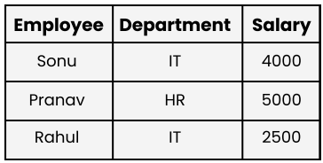
"Salary" (Largest to Smallest)? Write a step-by-step approach.

Ans2.
Step 1 : select the data and highlight the entire range of the table including the headers in
Most spreadsheet ensure that the rows stay intact

Step 2 : we are not direct switch quick “A-Z” toolbar buttons, Usually only support one
Column at a time.

- Excel go to Data > Sort.

Step 3 : In the dialog box

- Ensure “ Data has header row” Is checked
- Choose sort by “Department”
- Order A to Z

Step 4 : Add the secondary level (Salary)

- Click add level
- Choose then by Salary
- Order Largest to smallest (Z to A)

Q3. Explain the use of text functions such as TRIM , LEFT, RIGHT, MID, and CONCAT in Data
Cleaning.

Ans3. The Text Cleaning Toolkit
- Trim : Deletes invisible spaces at the start or end of a name.
- Left / Right : Chops off a specific number of characters from the start (Left) or end (Right).
- Mid: Reaches into the middle to grab a specific piece (like an area code).
- Concat : Acts as glue to combine two cells into one (like First Name + Last Name).

Q4 . What is the role of date functions like TODAY in managing datasets?
Ans 4. The TODAY() function makes your data dynamic. Instead of typing the date every
Morning, the spreadsheet updates itself.

3 Main roles in this function.

- Deadlines : Flags tasks that are past due to by comparing due date to Today ()
- Aging : Calculates exactly how many days in invoices or ticket has been open.
- Tenure : Tracks exactly how long someone has worked at a company
(Years/Months/Days) As or right now

Q5 . Apply Data Validation to restrict Quantity values to only whole numbers between 1
and 10.

a. Configure an input message that appears when a user selects a cell in the "Quantity" column explaining:
"Please enter a whole number between 1 and 10."

b Set up an error alert message that triggers if the user enters a number less than 1 or greater than 10,
showing:
"Invalid input! The quantity must be a whole number between 1 and 10.

Write a step-by-step approach for this question
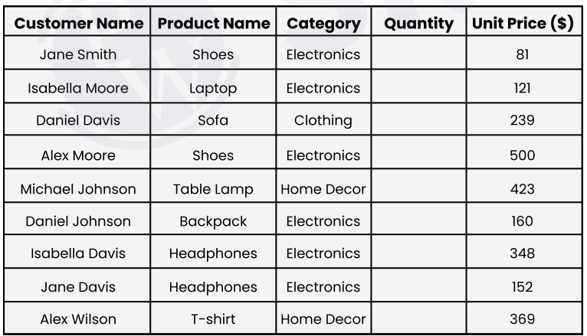

Ans 5. To restrict quantity column in your dataset. Follow these steps to setup
Data Validation :

Step 1 Select the range
- Highlight all the empty cells under the quantity header from the row with jane smith down to Alex Wilson

Step 2 Open data validation
- Go to the data tab on the ribbon
- Click on data validation.

Step 3 In the dialog box that appears, configure the Settings tab:
- Allow : select whole number
- Data: Select between.
- Minimum: Type 1.
- Maximum: Type 10.

Step 4. Add the Guidance (Input Message Tab)
Title: (Optional) Type Quantity Guide.
Input message: Type: "Please enter a whole number between 1 and 10."
This will pop up like a sticky note whenever a user clicks a cell.

Step 5. Set the Restriction (Error Alert Tab)
- Style: Select Stop (this prevents the user from entering bad data entirely).
- Title: Type Error.
- Error message: Type: "Invalid input! The quantity must be a whole number B/W
1 to 10.x`

Q 6. Understand and apply fundamental text functions like LEFT, RIGHT, MID, and LEN.
- Extract the first 5 characters from the string "ExcelTipsAreGreat" using the LEFT function.
- Extract the last 4 characters from "DataAnalysis.xlsx" using the RIGHT function.
- Extract the substring "Tips" from "ExcelTipsAreGreat" using the MID function.
- Count the total number of characters in the string "Hello World!" using the LEN function.
- Create a formula to extract the middle 6 characters from "12345-67890-ABCDE".
Ans 6. (1) Left : Extracting from the start.

Goal: Get the first 5 characters of "ExcelTipsAreGreat".
Formula: =LEFT("ExcelTipsAreGreat", 5)
Result: "Excel"

(2) Right : Extracting from the end

Goal: Get the last 4 characters of "DataAnalysis.xlsx".
Formula: =RIGHT("DataAnalysis.xlsx", 4)
Result: ".xlsx"

(3) Mid : Extracting from the middle

Goal: Get "Tips" from "ExcelTipsAreGreat".
Formula: =MID("ExcelTipsAreGreat", 6, 4)
Explanation: Start at the 6th character ("T") and take 4 characters.
Result: "Tips"

(4) Len : The character counter

Goal: Count characters in "Hello World!".
Formula: =LEN("Hello World!")
Result: 12 (Note: The space and exclamation mark count as characters).

(5) Extract middle 6 characters

String: "12345-67890-ABCDE"
Goal: Extract "67890-".
Formula: =MID("12345-67890-ABCDE", 7, 6)
Logic: The 7th character is "6". Taking 6 characters from there captures "67890-".

Q7. Understand how to combine text using CONCAT, TEXTJOIN, and the & operator.
- Use CONCAT to combine "Hello" and "World" with a space in between.
- Combine "Apple", "Banana", and "Cherry" into a single string separated by commas using TEXTJOIN
- Use the & operator to create the string "2025: Excel Functions" by combining "2025", ": ", and "Excel Functions”
- Create a comma-separated list from the range A1:A5 using TEXTJOIN
- Create a comma-separated list from the range A1:A5 using TEXTJOIN

Ans7. (1) Concat : The basic join

Goal: Combine "Hello" and "World" with a space.
Formula: =CONCAT("Hello", " ", "World")
Result: "Hello World"

(2) Textjoin : The advanced “Smart” Join

Goal: Combine "Apple", "Banana", "Cherry" with commas.
Formula: =TEXTJOIN(", ", TRUE, "Apple", "Banana", "Cherry")
Logic: The first part ", " is your delimiter (separator); TRUE tells Excel to skip empty
Cells
Result: "Apple, Banana, Cherry"

3. The & Operator: The Quick "Glue"

Goal: Create "2025: Excel Functions".
Formula: ="2025" & ": " & "Excel Functions"
Result: "2025: Excel Functions"

4. TEXTJOIN with a Range

Goal: Create a comma-separated list from cells A1 through A5.
Formula: =TEXTJOIN(", ", TRUE, A1:A5)
Result: A single cell containing all values from that range (e.g., "Item1, Item2, Item3...").

5. Full Name Creation (Column A + Column B)

Goal: Join First Name (A2) and Last Name (B2) into Column C.
Formula: =A2 & " " & B2
Alternative: =CONCAT(A2, " ", B2)
Result: If A2 is "Jane" and B2 is "Smith", C2 becomes "Jane Smith".

Q8. Understanding TODAY() and NOW()

